**Use case Create customer Profile: Simple**

First cut design class diagram:

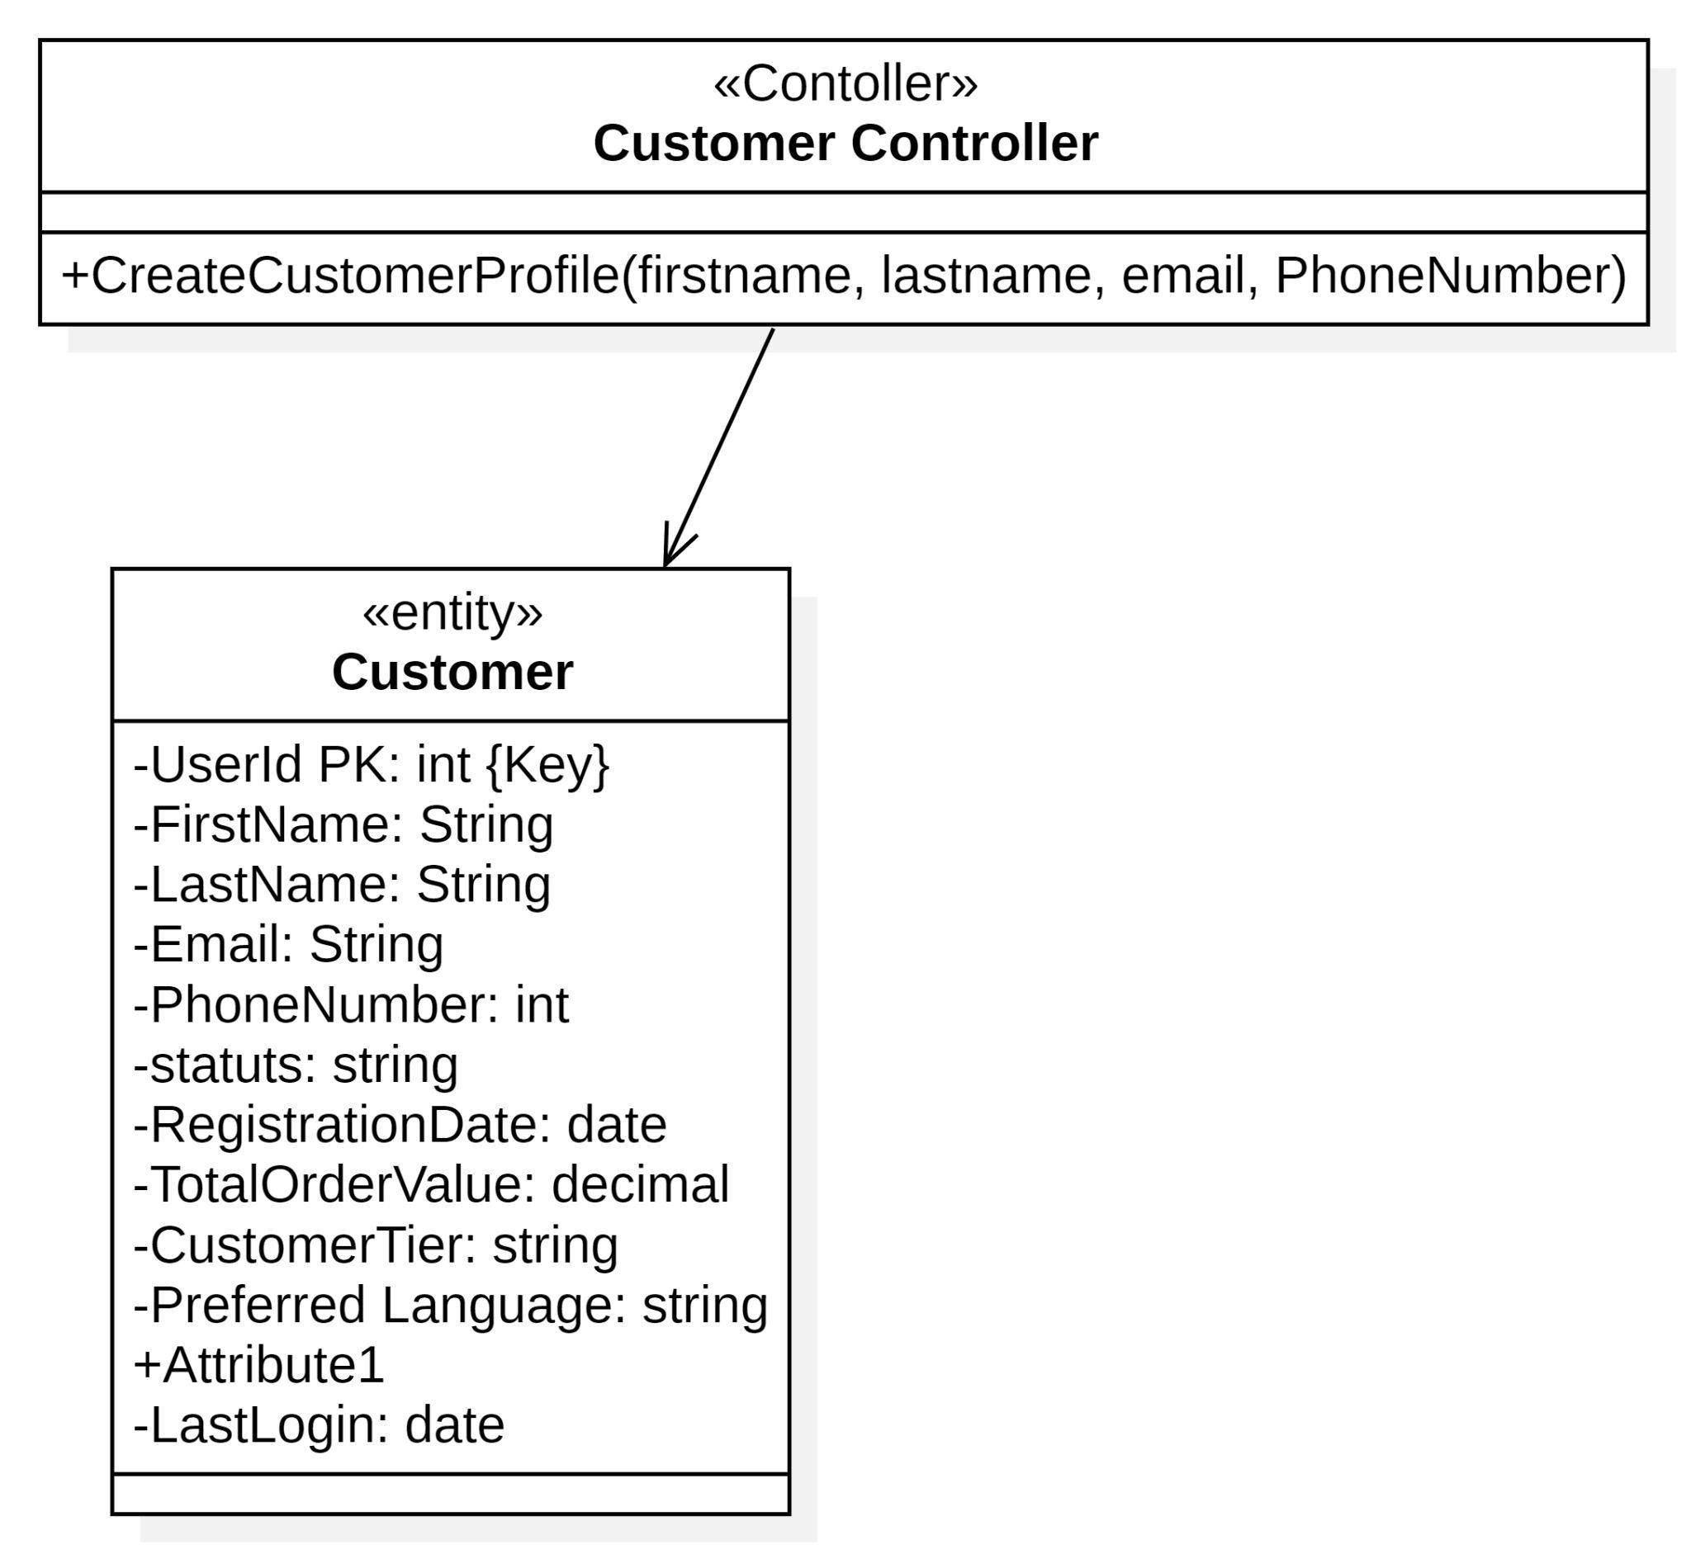

CRC:

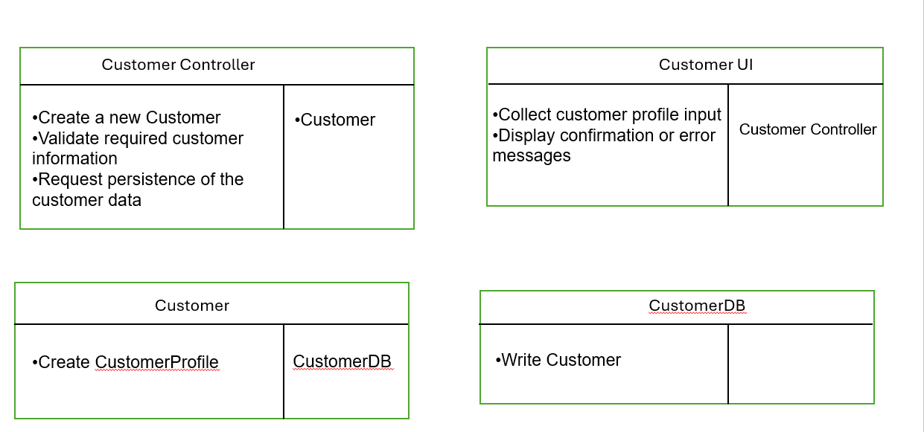

Final Design class Digram:

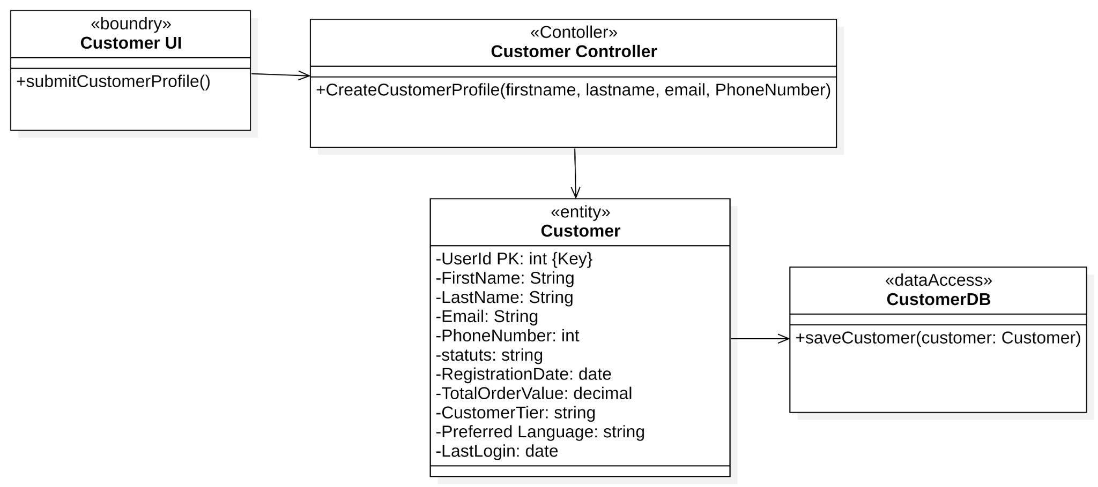

**Use Case**: **Retrieve Customer Information :Moderate**

**first Cut Design Class diagram:**

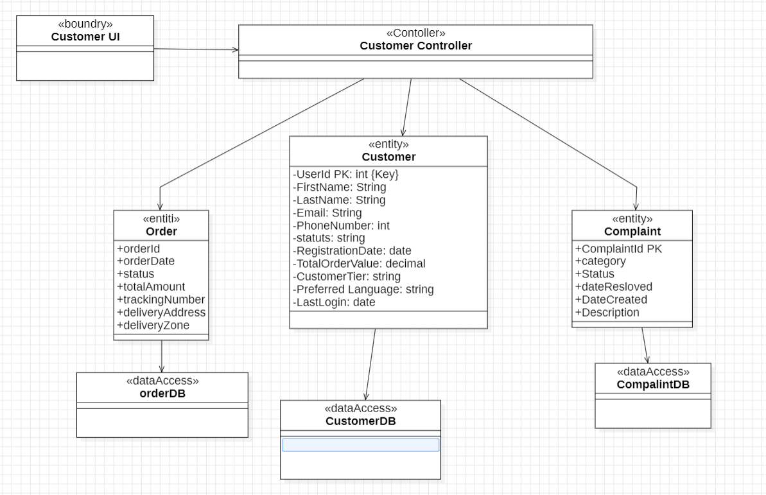

rrrrrrrrrrrrrrrrrrrrrrrrrrrrrrrrrrrrrrrrr

Communication Diagram:

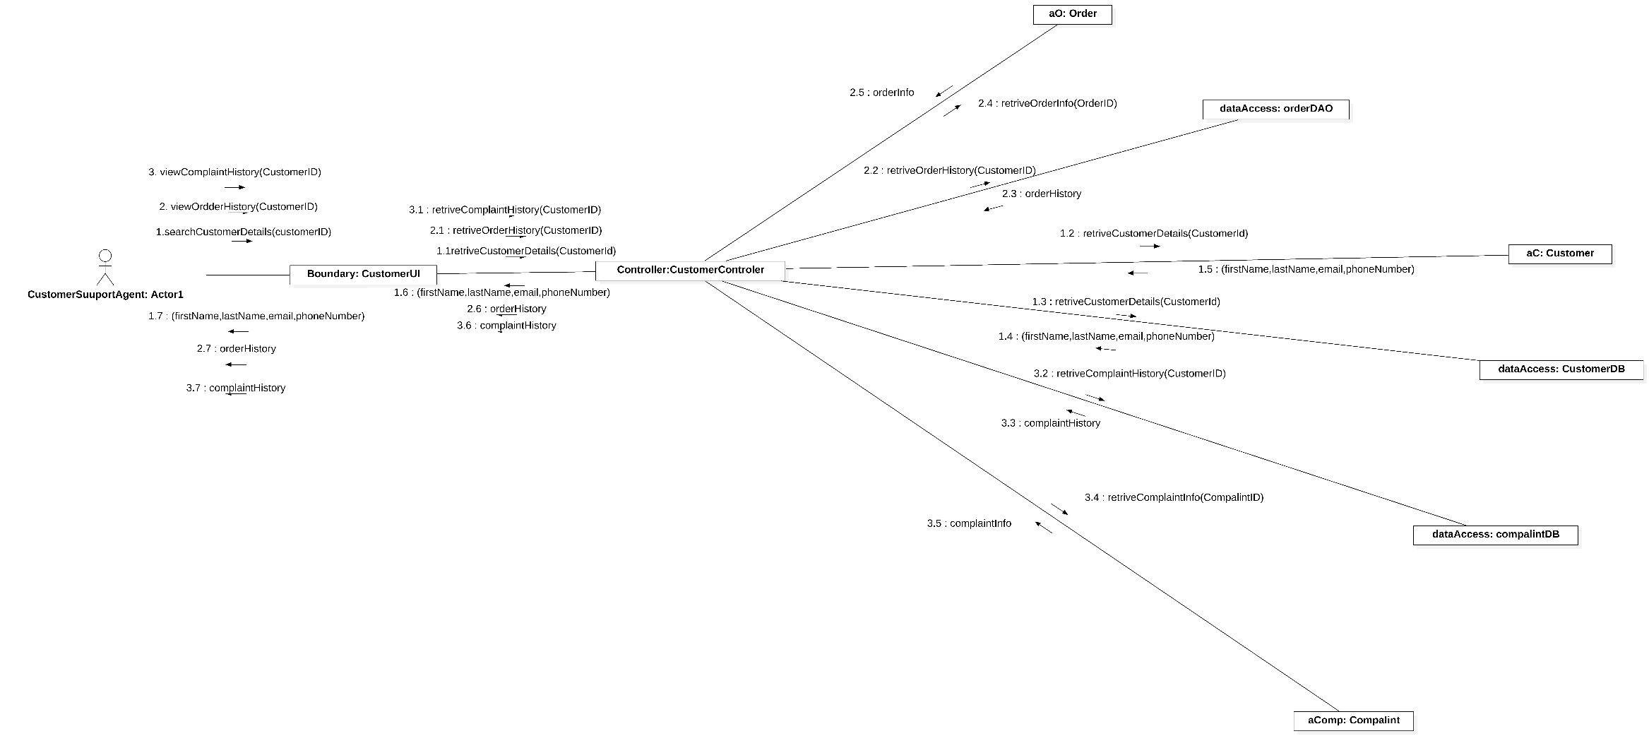

Final design Diagram:

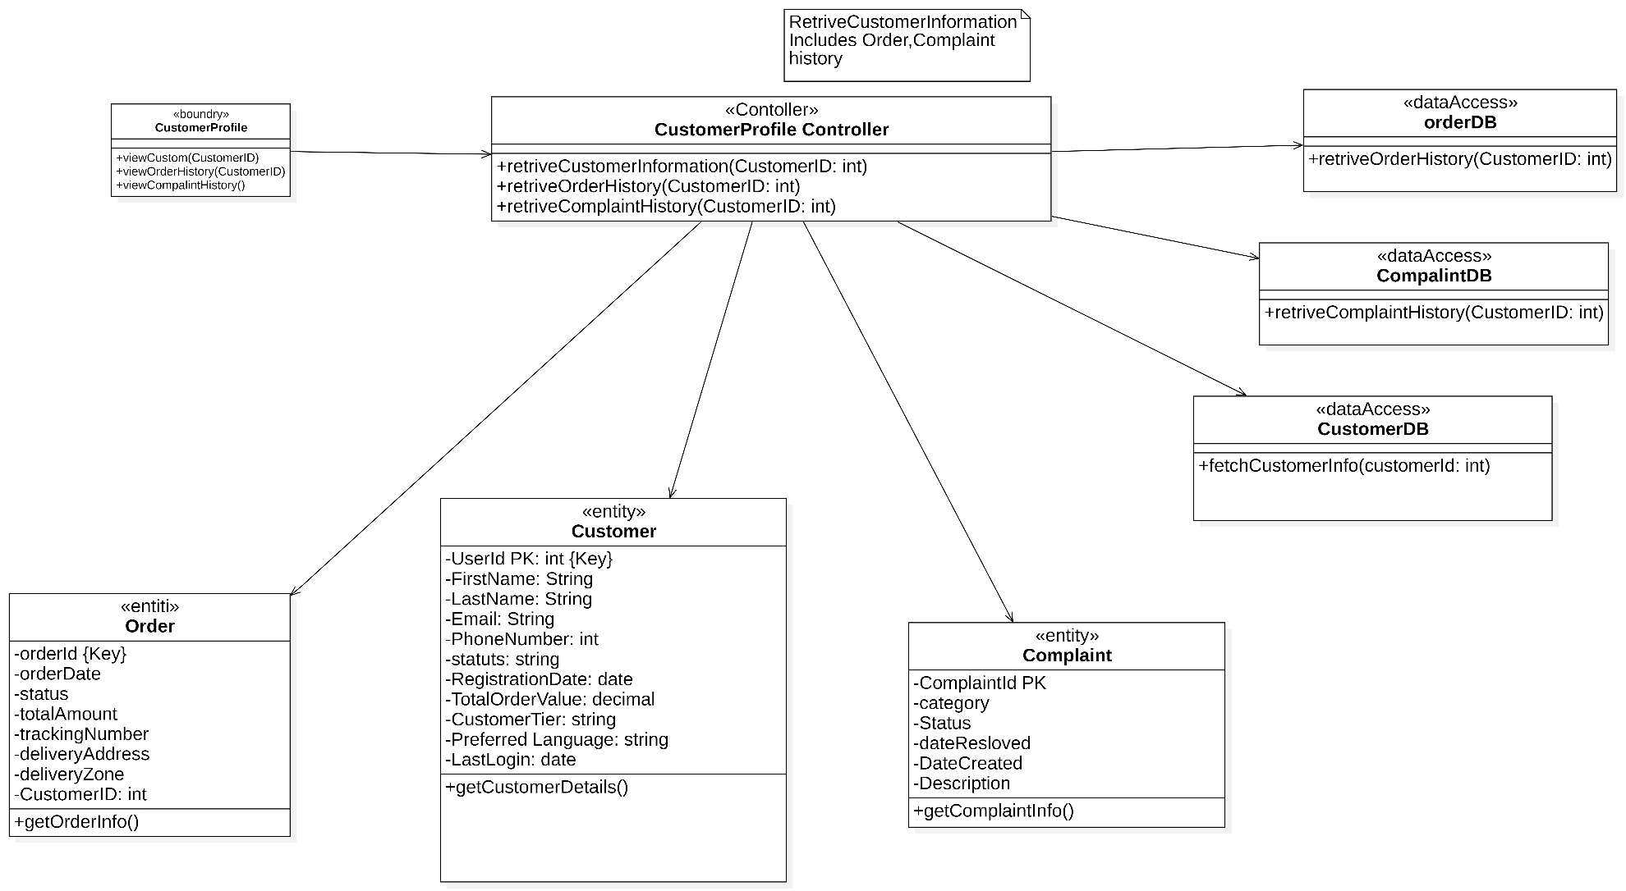

**Update customer status:**

First cut edge:

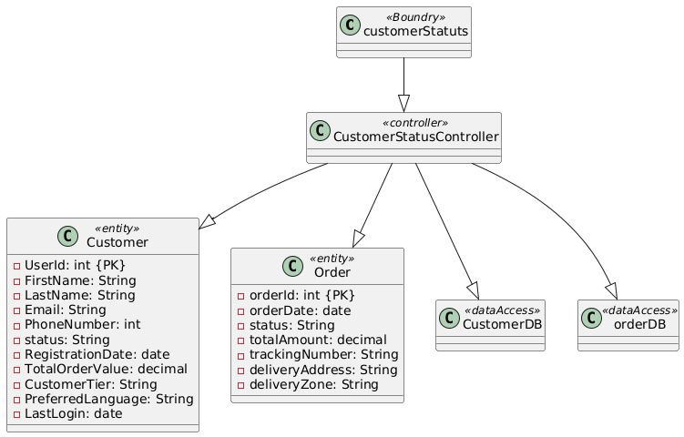

Multi layer sequence diagram:

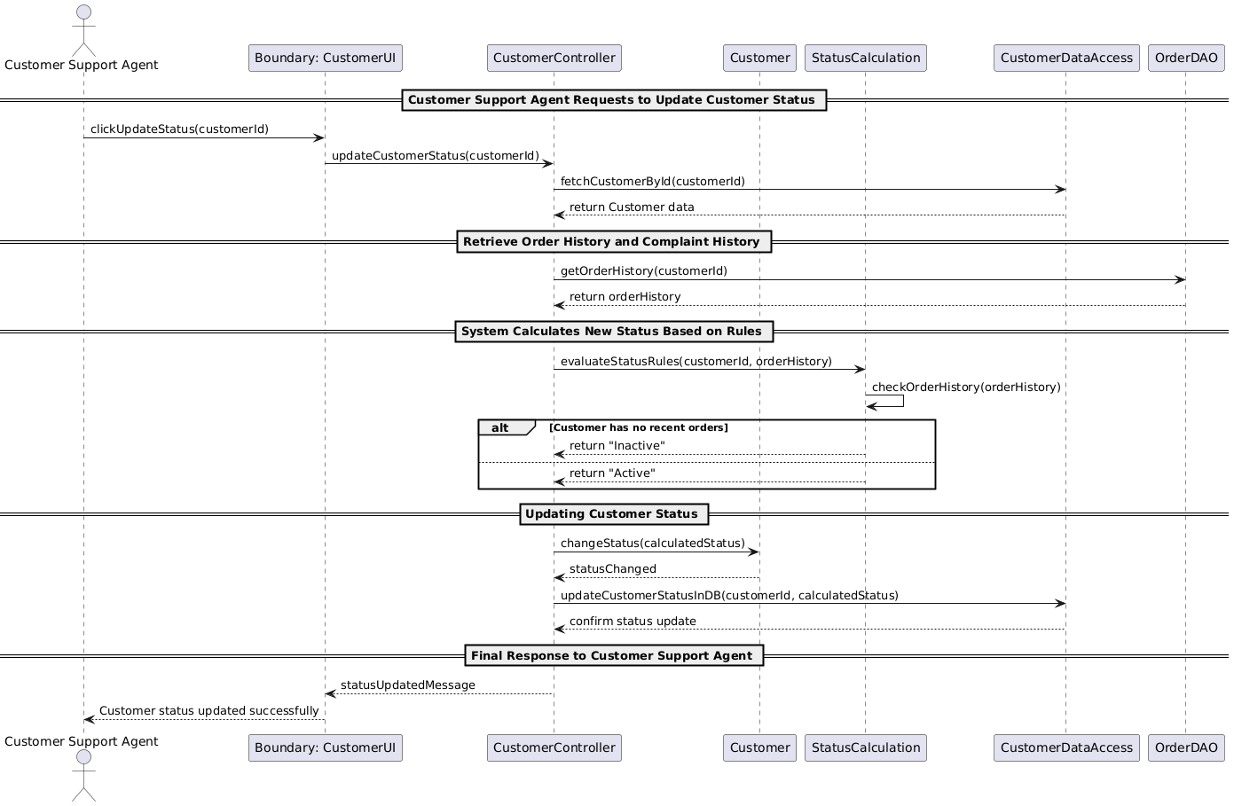

Final design :

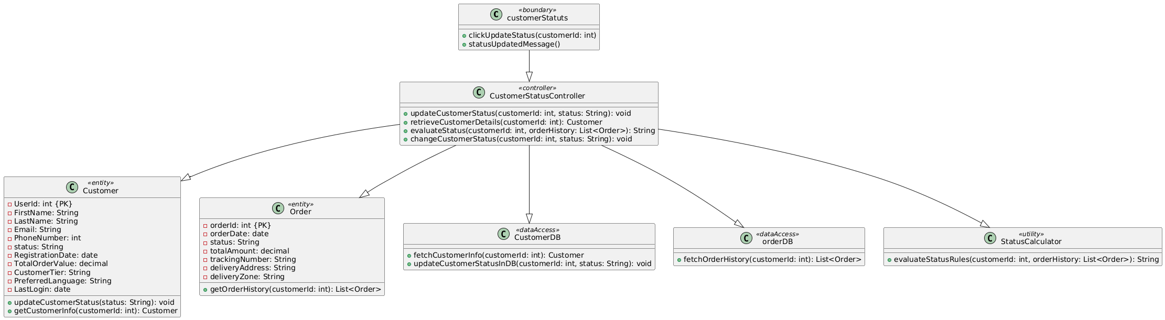

Use Case 1: Create Complaint Record(Simple)

* First-Cut DCD Before CRC:

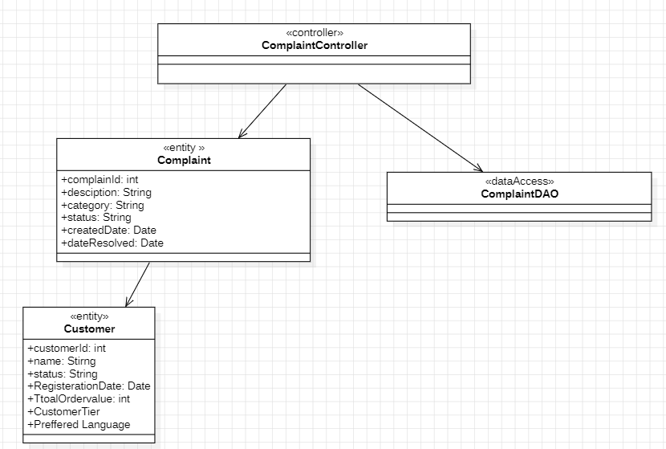

CRCs for create complaint record:

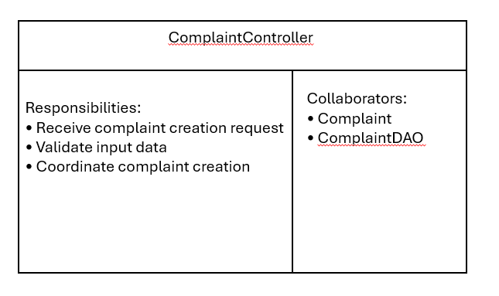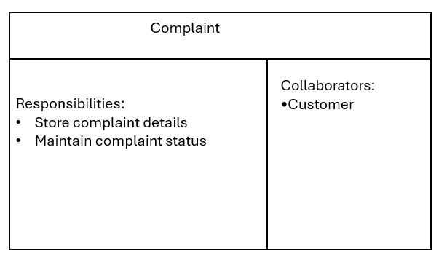

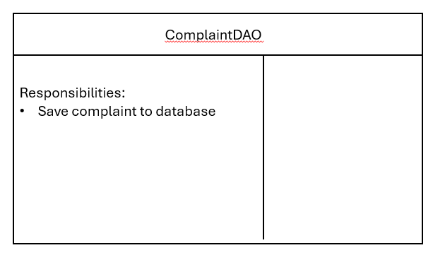

DCD After CRC:

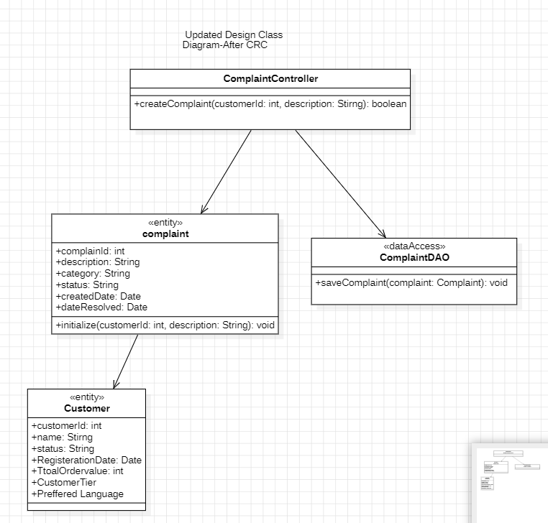

Use Case 2: Resolve Customer Complaint(Moderate)

* First-Cut DCD before communication Diagram:

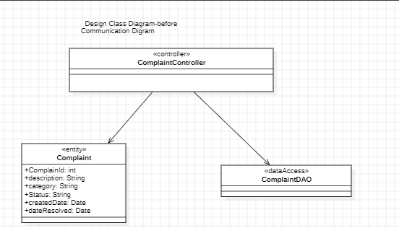

Communication Diagram:

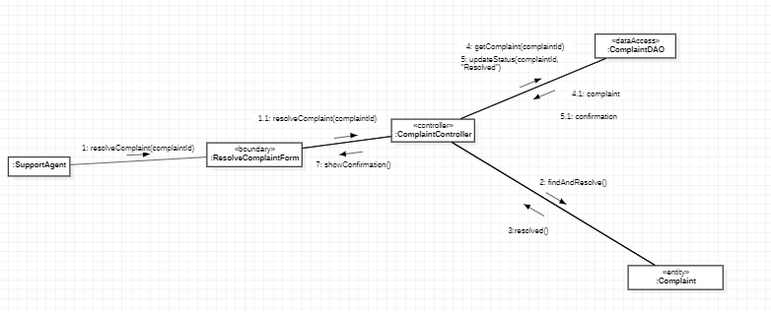

DCD after communication Diagram:

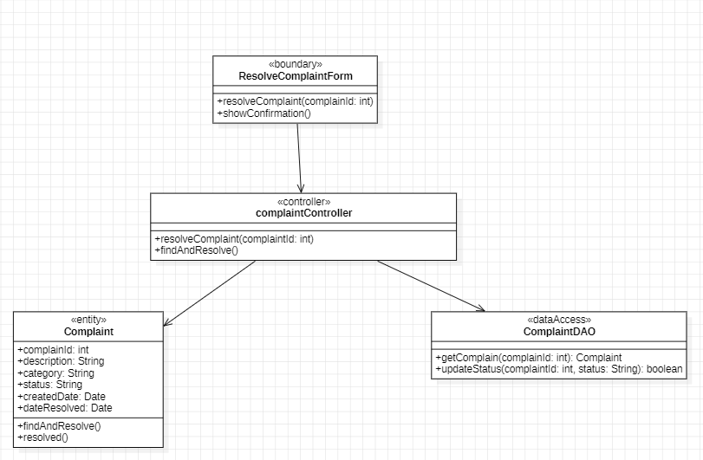

Use Case 3:Escalate Unresolved Complaint (complex):

* First-Cut DCD before Sequence Diagram:

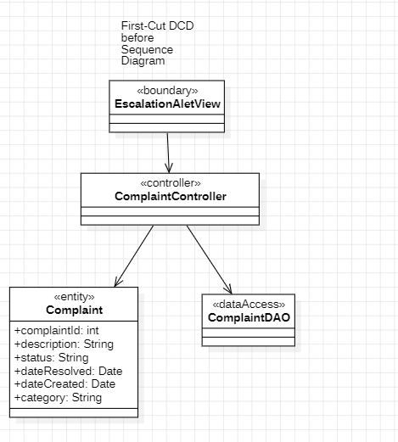

Sequence Digram:

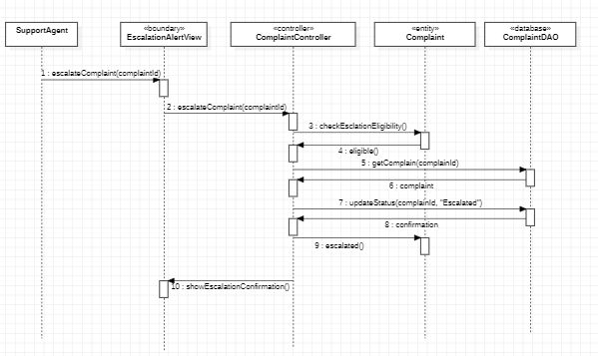

DCD after Sequence Diagram:

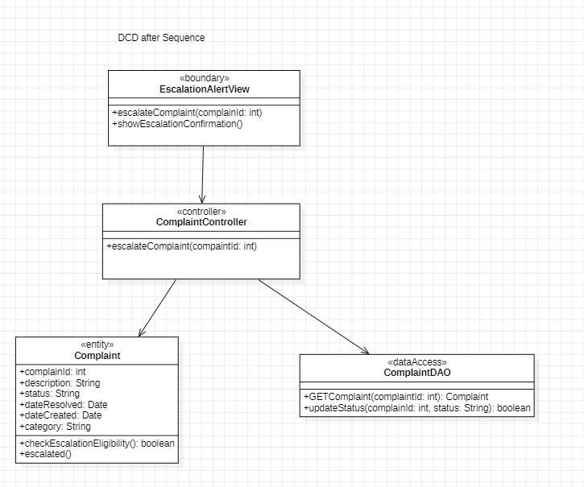

### **Use case :Send Message To customer:**

**First DCD:**

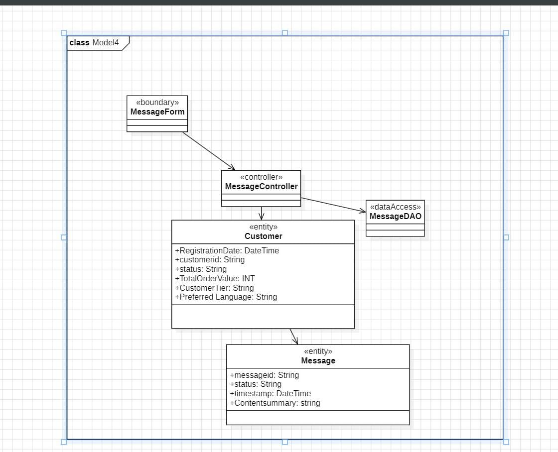

### **CRC Card: MessageController**

|  |  |  |
| --- | --- | --- |
| **Class** | **Responsibilities** | **Collaborators** |
| **MessageController** | **• Accept send message request**  **• Validate message content**  **• Delegate message creation and persistence** | **Customer, Message, MessageDAO** |

### **CRC Card: Message**

|  |  |  |
| --- | --- | --- |
| **Class** | **Responsibilities** | **Collaborators** |
| **Message** | **• Store message content**  **• Timestamp the message**  **• Link message to the corresponding customer** | **Customer** |

### **CRC Card: Customer**

|  |  |  |
| --- | --- | --- |
| **Class** | **Responsibilities** | **Collaborators** |
| **Customer** | **• Maintain customer profile**  **• Maintain customer message history** | **Message** |

### 

### **CRC Card: MessageDAO**

|  |  |  |
| --- | --- | --- |
| **Class** | **Responsibilities** | **Collaborators** |
| **MessageDAO** | **• Save message to the database**  **• Retrieve message history for a customer** |  |

**FINAL DCD**

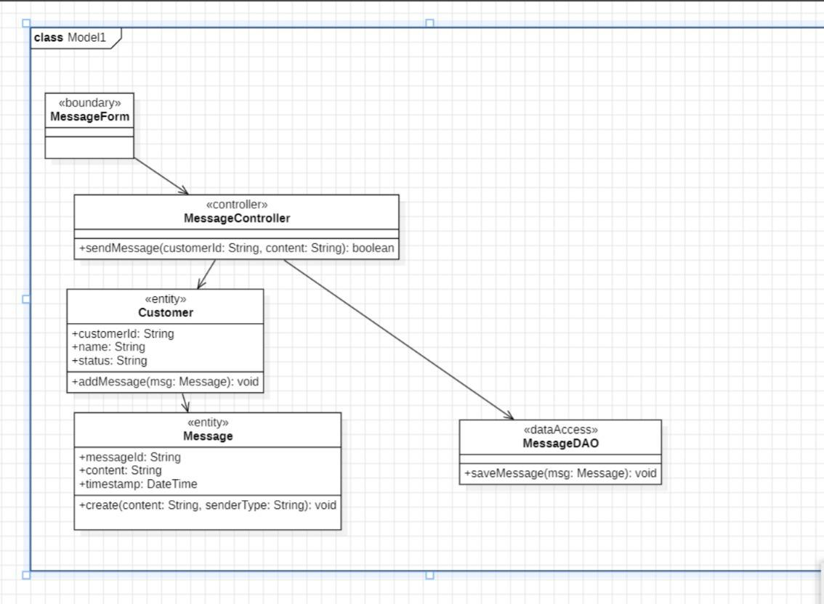

**Use Case: Receive and route customer Message**

**FIRST CUT DCD**

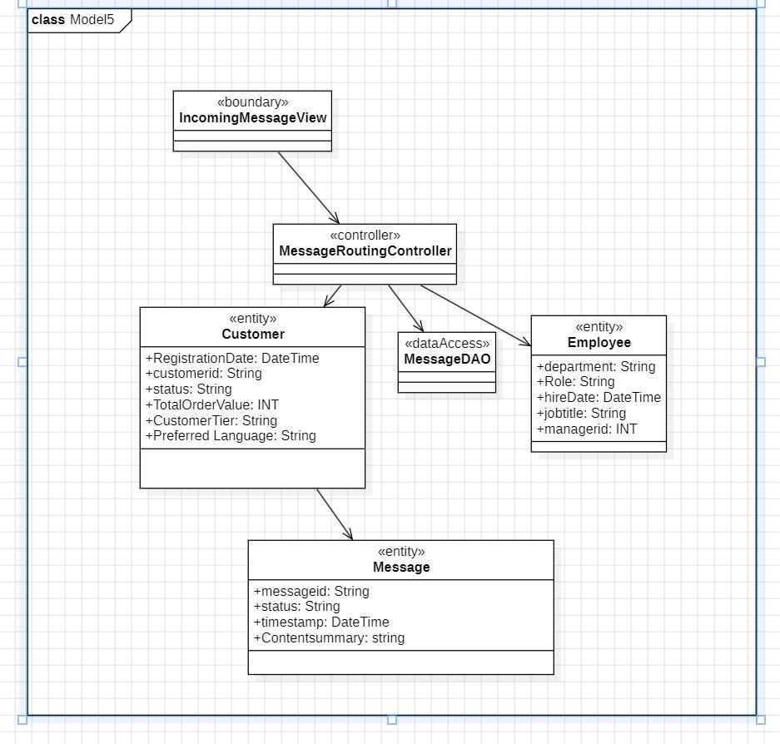

COMMUNICATION DIAGRAM

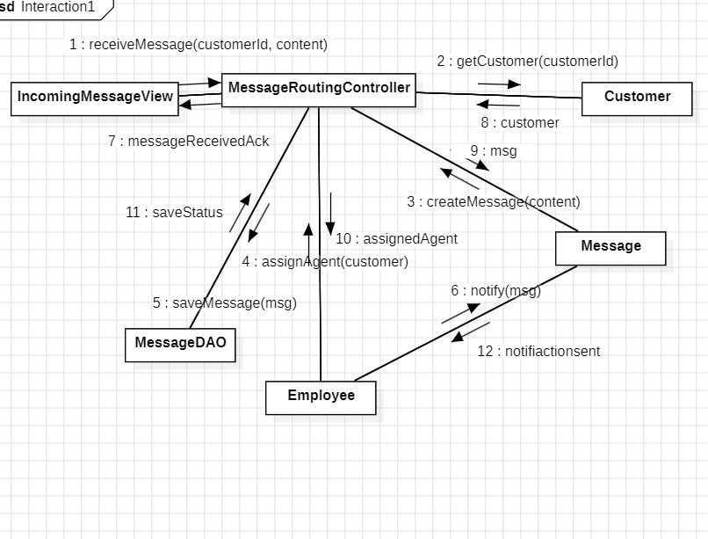

FINAL DCD

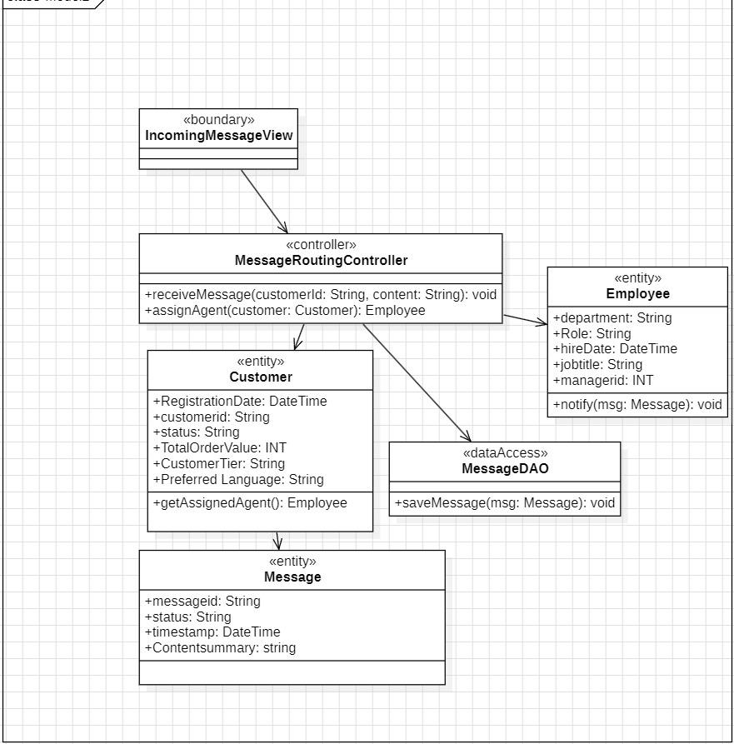

**Use Case: Generate Active Customer Report**

FIRST CUT DCD

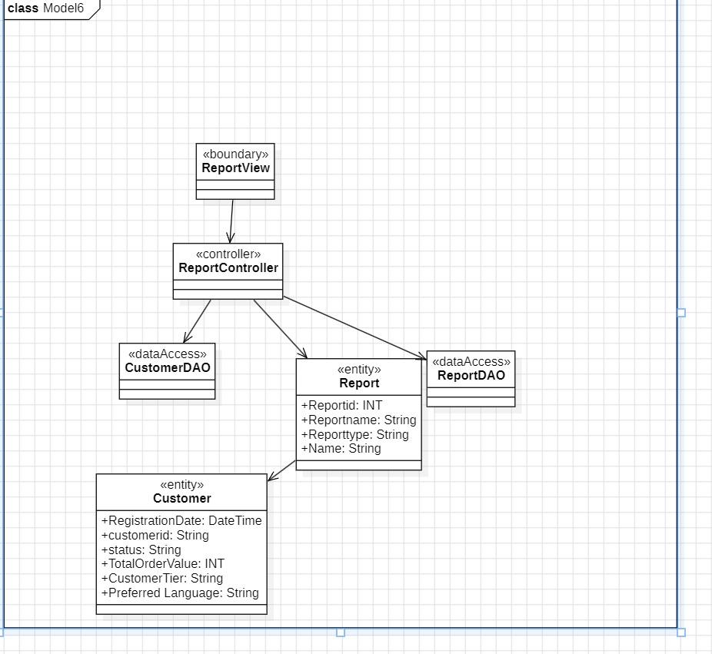

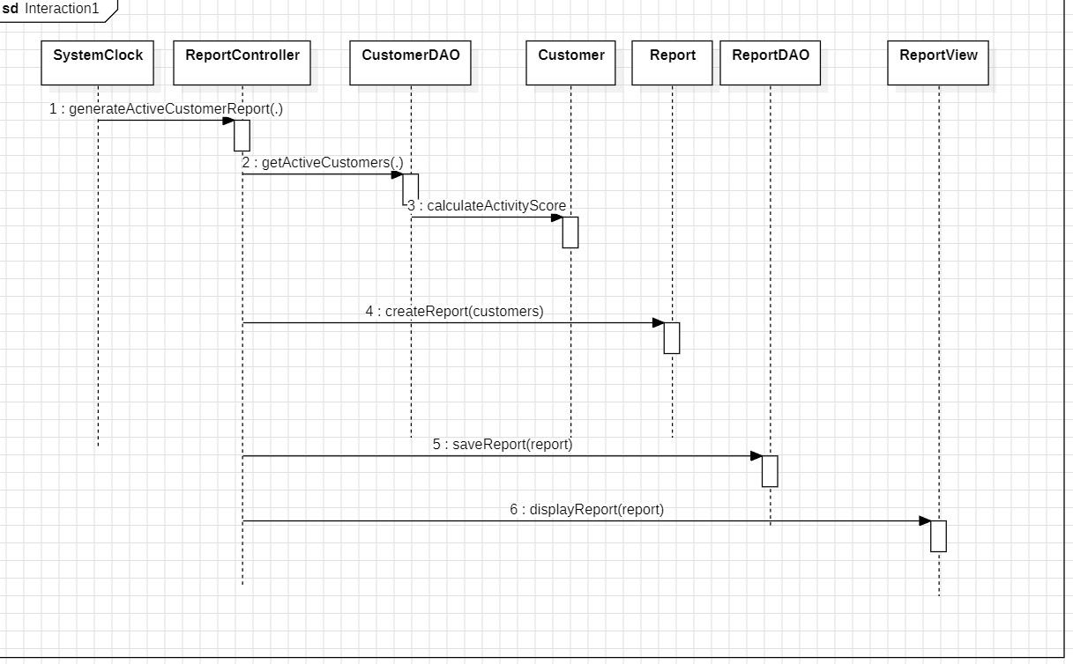SEQUENCE DIAGRAM

FINAL DCD

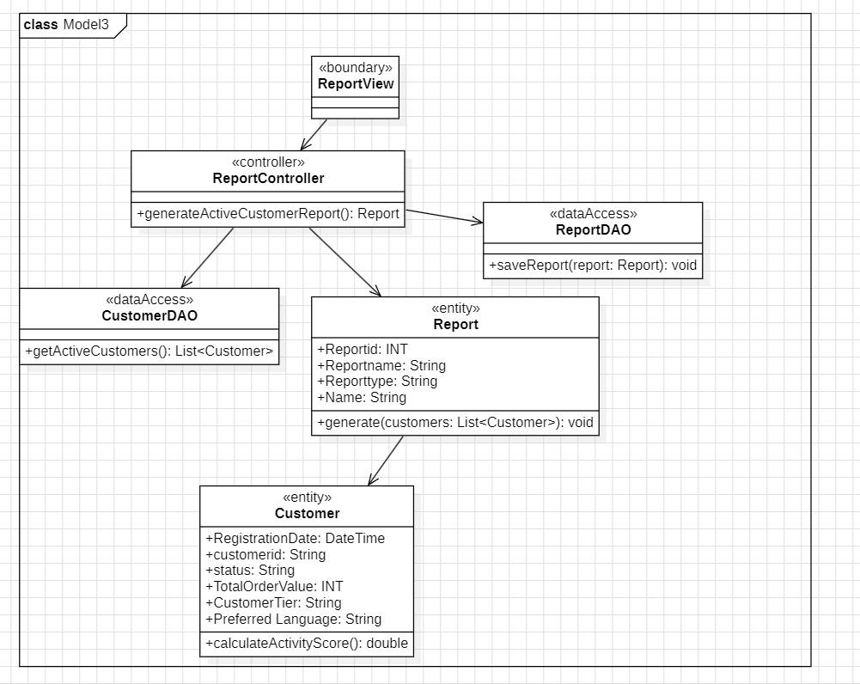

Update customer profile - first cut

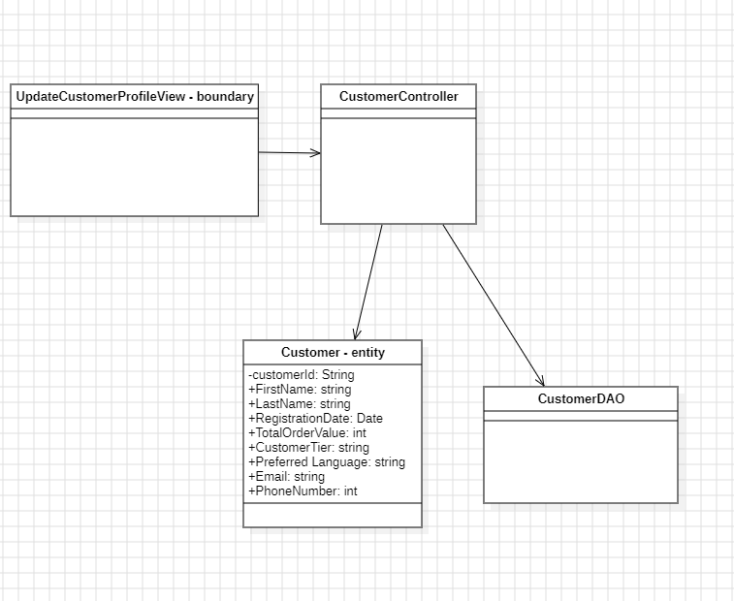

CRC:

Customer

Hold customer data

Apply profile updates

CustomerDAO

Customer DAO

Retrieve customer

Persist updates

Customer

Customer Controller

Receive update request

Validate input

Delegate update

Customer

CustomerDAO

DCD - final

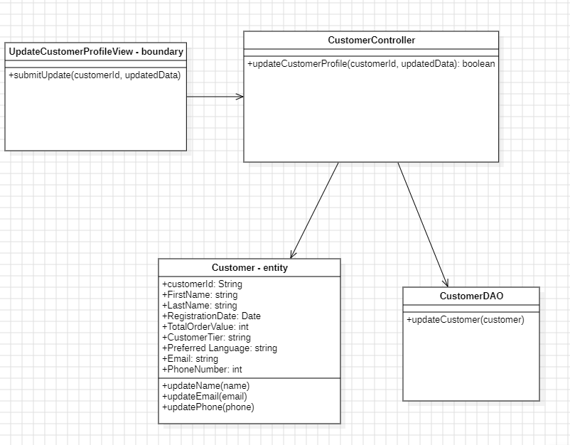

Generate customer summary

First cut

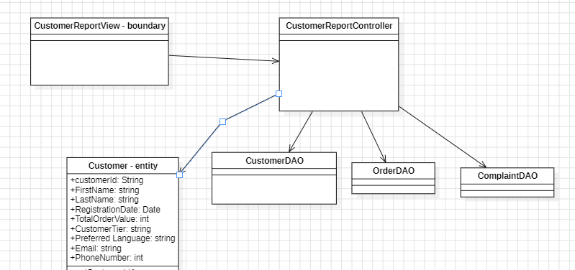

Communication diagram

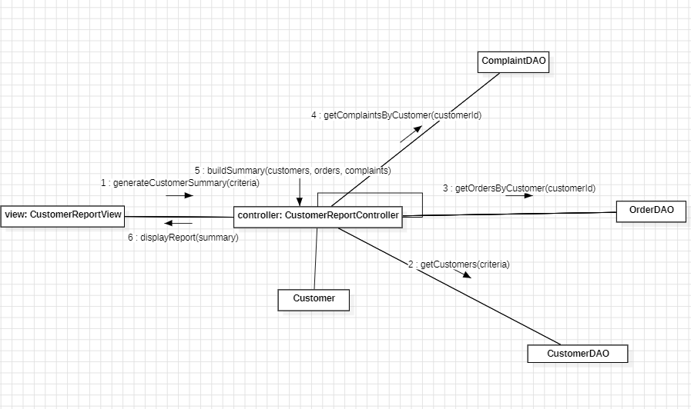

Final cut

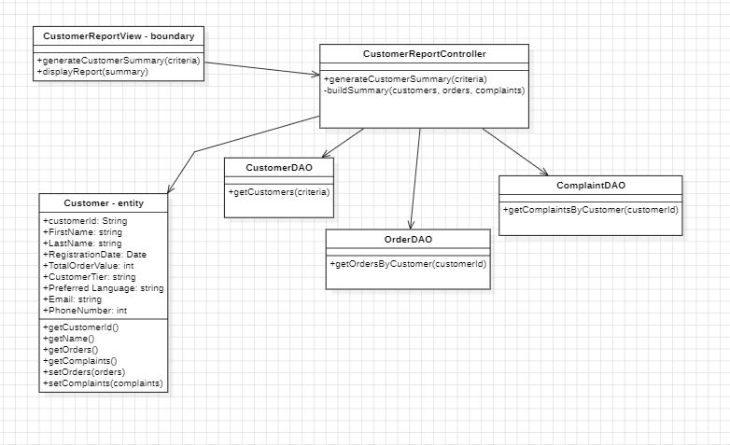

Generate Customer Segmentation Analysis

First cut

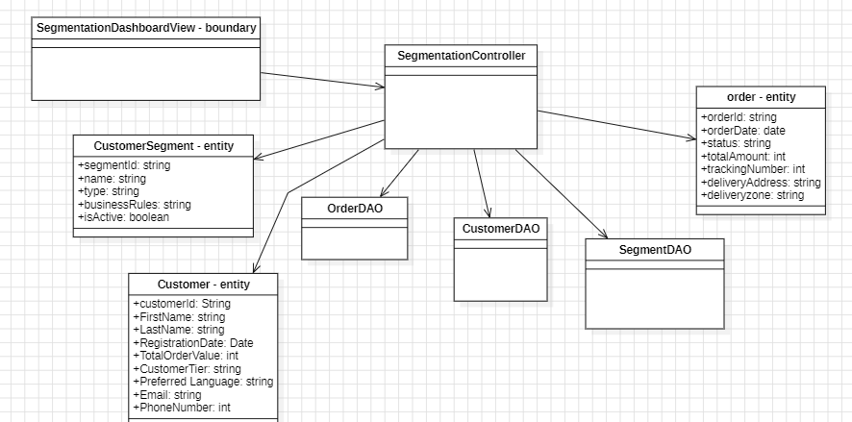

Sequence diagram:

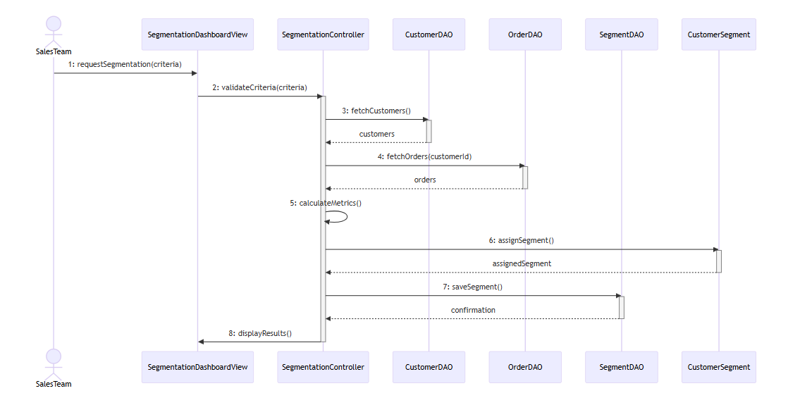

Final cut

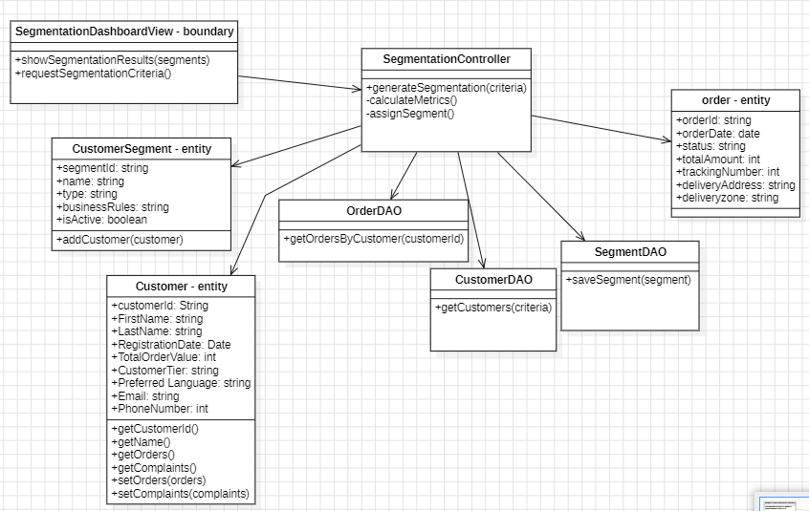

**Final Design Diagram:** will be in the zip file dues to the resolution issues

**Package Diagram:**